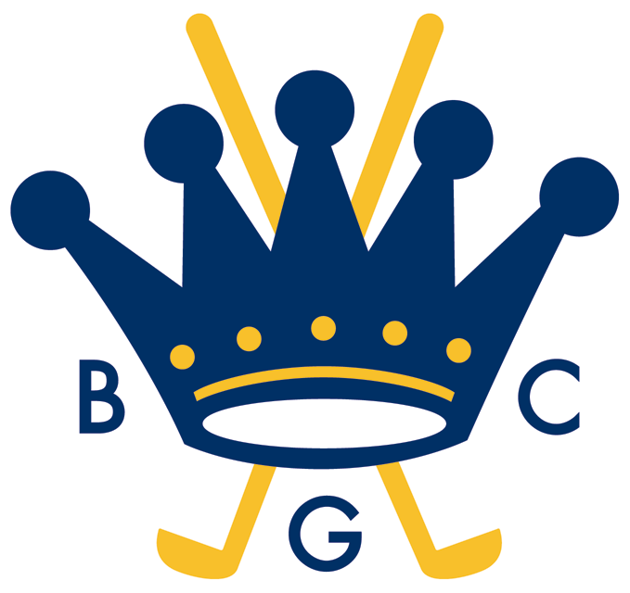
BOWRAL GOLF CLUB

2013 CLUB MIXED FOURSOMES CHAMPIONSHIP
2013 CLUB MIXED FOURSOMES HANDICAP for the Wotton’s Trophy

Conditions of the Competitions

- History
The Club Mixed Foursomes Championship was first played in 1980 with winners recorded on the Honour Board. The first winners were P K Douglas and Mrs D Missingham. The current holders are Brian Hanrahan and Stephne Whitway.
The Club Mixed Foursomes Handicap originated in 1993 with the winners awarded the Wotton Trophy which had been donated by Mr and Mrs R K Wotton. The first winners were P K Douglas and Mrs D Missingham. The current holders are Brian Hanrahan and Stephne Whitway.

- The Club Mixed Foursomes Championship and Mixed Foursomes Handicap are limited to Eligible Members (ie, Mixed, Full Playing Members, Honorary Life Members, Former Life Members, Six Day Playing Members, Visiting Members, City Members, Intermediate Members, Junior Playing Members, Sub Junior Playing Members and Corporate Members) of Bowral Golf Club. Both events will be played in accordance with the Rules of Golf and the Local Rules of Bowral Golf Club Limited. The standard entry fee will cover both events.

- Club Mixed Foursomes Championship
The Mixed Foursomes Championship is a scratch stroke event, played over 2 rounds of 18 holes on Sundays 7th and 14th April. In the round, each team player must tee off on an alternate sequence of holes eg, round 1 – player A even holes and player B odd holes; round 2 - player A odd holes and player B even holes. All teams must have a marker for each round and must submit their score card by 3:00pm. In the event of a tie after round 2, a sudden death play-off to determine the winners will commence at 3:30pm.
N.B. Score cards for round 2 submitted after 3:00pm will not be considered for the Championship.

- Club Mixed Foursomes Handicap – Wotton’s Trophy
The Mixed Foursomes Handicap is a handicap stroke event, played in conjunction with the two rounds of the Club Mixed Foursomes Championship. Club handicaps applicable to Round 1 will also apply to Round 2. All teams must have a marker for each round. In the event of a tie after Round 2, the winners will be determined by count-back.

- The names of the winners of the Mixed Foursomes Championship will be inscribed on the Club Foursomes Championship Honour Board. The winners will each receive a voucher for entry and complimentary food for two at the Club’s Annual Presentation of Trophies Dinner. The runners-up will each receive a voucher for entry and complimentary food for one at the Club’s Annual Presentation of Trophies Dinner.
- The names of the winners of the Mixed Foursomes Handicap will be engraved on the Wotton’s Trophy. The winners and runners-up will each receive a voucher for entry and complimentary food for one at the Presentation of Trophies Dinner.

Kevin Burke, Captain
April 2013

